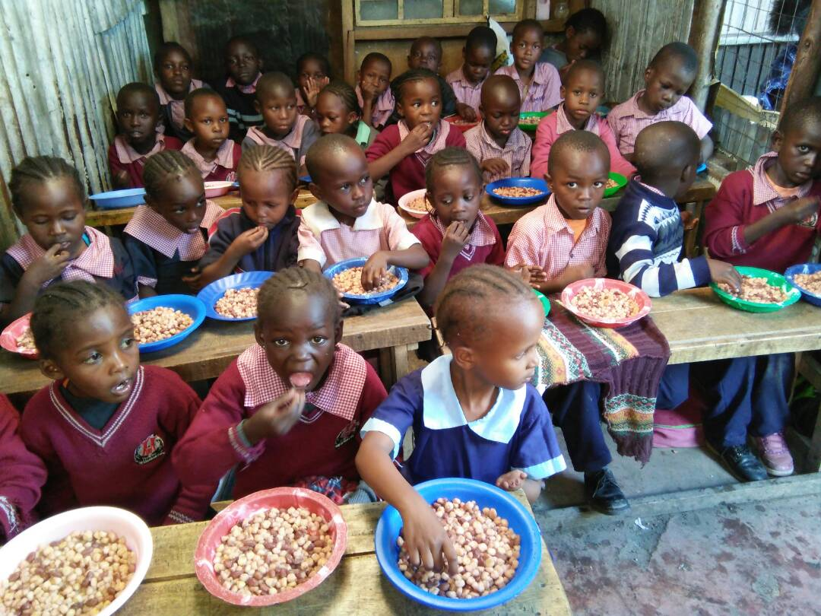
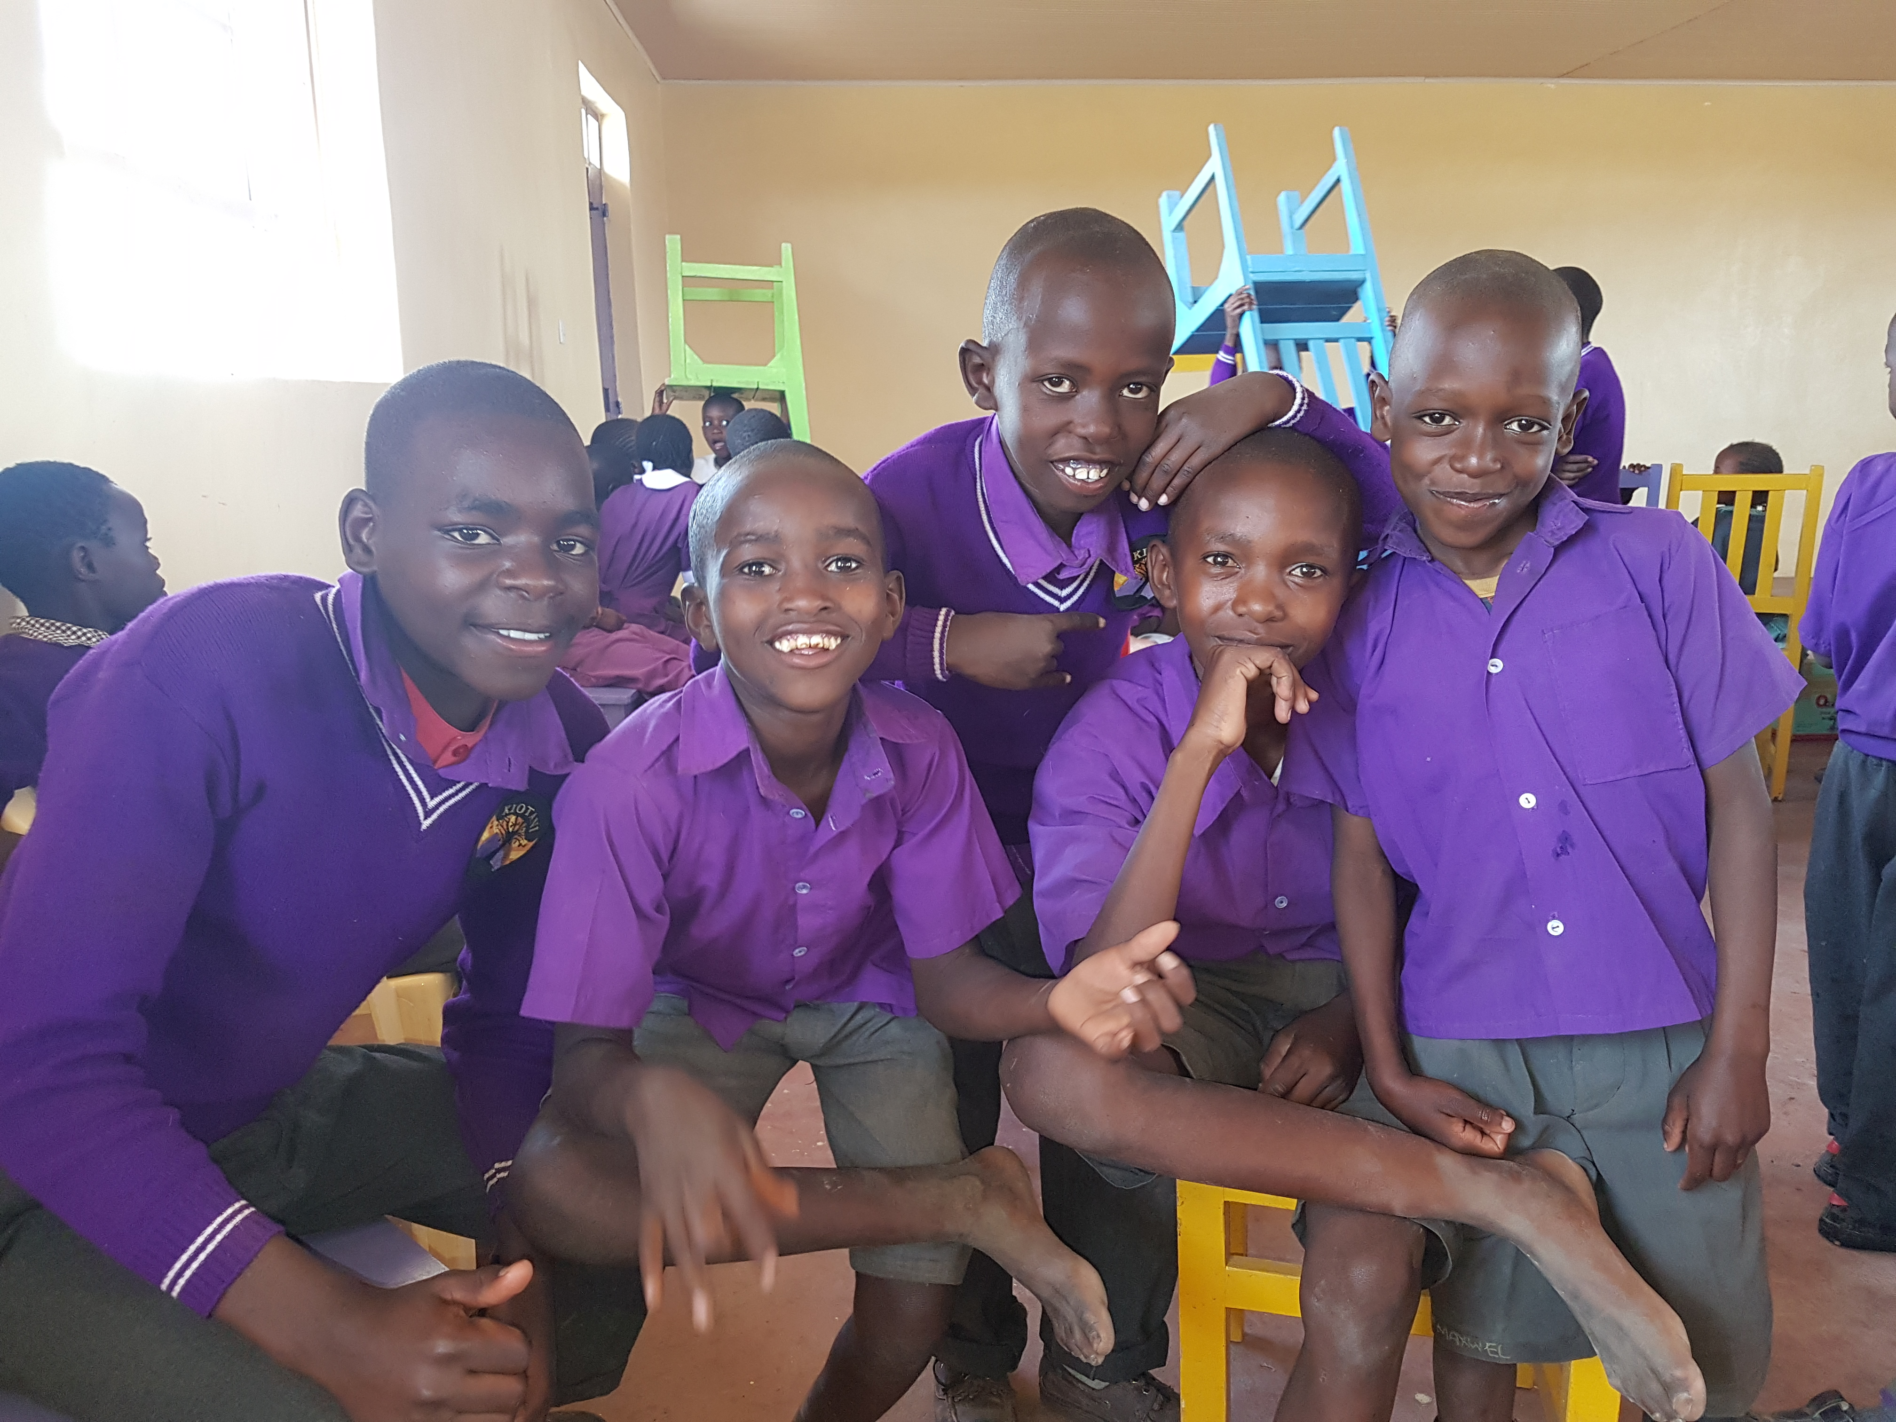



Banking Information

Contact a Representative Today:
.

..Empowering families affected by HIV/AIDS…

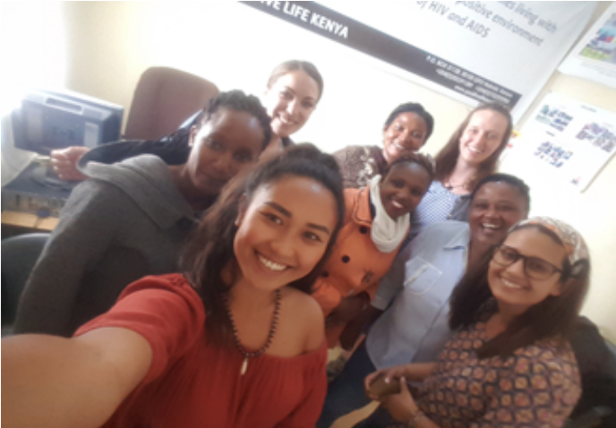
I would like to thank all our friends for the love, care and support that you have shown to PLK beneficiaries. Over the years we have walked this amazing wonderful journey together, on this newsletter will be happy to share some updates on “the fruits our work”
We are happy to introduce this newsletter which will highlight the activities of what we are doing in the program and the same time keeps our friends and partners informed. The news and updates which is a mix of our achievements and challenges is hoped that will come monthly. The achievements we have had in recent days include the chairs in our dining hall and the biogas. We can use clean energy in our new kitchen.
Karibu sana

From Positive Life Kenya Desk
Mary Wabwire
Executive Director

NEWS FROM PLK DESK
NEWS FROM THE JUNIOR BOARD

Updates on Sponsorship/ Donation Pay bill
Soon PLK will share the new method of sending money through MPESA Paybill Number –a Mobile phone platform where you can send small or large donations from your phone!!

Watch this space!
PLK Junior board was formed to strengthen the work of PLK. They have great ideas on fundraising, networking and how to make our activities vibrant in an environment of love. They have documented all their plans and have a communication strategy that is working very well.

We are encouraging all our interns who might be interested to join this board to contact us for details.
We will continue to provide periodical updates on their good work. Keep up our junior board!!

IN OTHER NEWS!!
Heavy rains have been wreaking havoc in Kenya; most of you may have seen that on global news, social media and our Facebook page.
The rains have destroyed houses in the slums, and some children have fallen ill and some of their houses submerged in water. Roads are impassable; going to Kiotani is nightmare due to bad road network. We hope that situation will normalize soon.
Did you hear of the great earth (rift valley) crack in Narok towards the maasai mara? This happened due to heavy rains!

PLK MAY 2018 NEWSLETTER-
SMILE EDITION
P.O. BOX 51128, 00100 GPO Nairobi, Kenya.
MOBILE
+254(0)202391389
+254(0)722393983
Web: www.positivelifekenya.org
Email: info@positivelifekenya.org


NEWS FROM TUMAINI SCHOOL
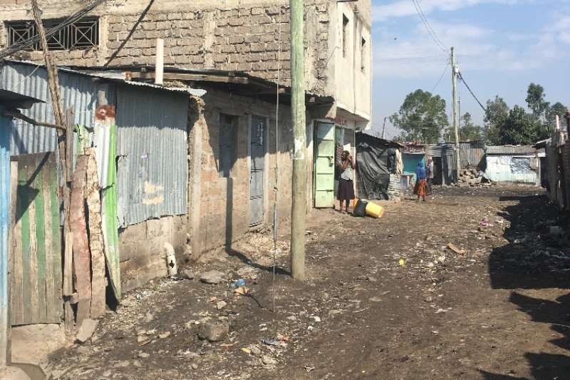
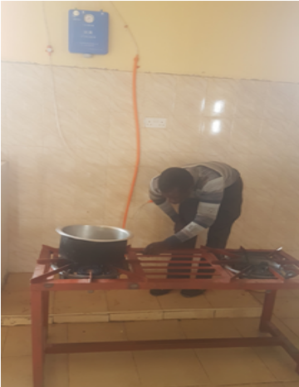
NEWS FROM KIOTANI SCHOOL
Kiotani has become a safe net, a beacon of hope and the only vessel that will take the supported children into the future, with that in mind we cannot compromise on service delivery, academic excellence and holistic growth of the children.

We have therefore recruited a professional teacher with over 15 years of experience in teaching and managing Schools. His career goal is Interdem with PLKs vision hence the best suited for that role,

Joining us in welcoming Teacher Michael!!

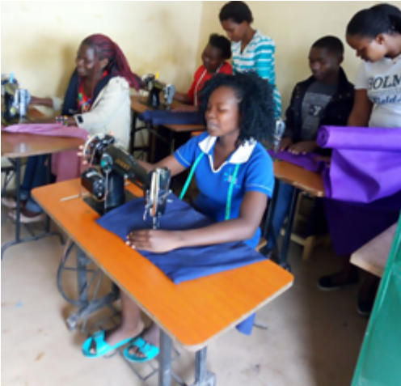
WEEP (Women Economic Empowerment Program) NEWS

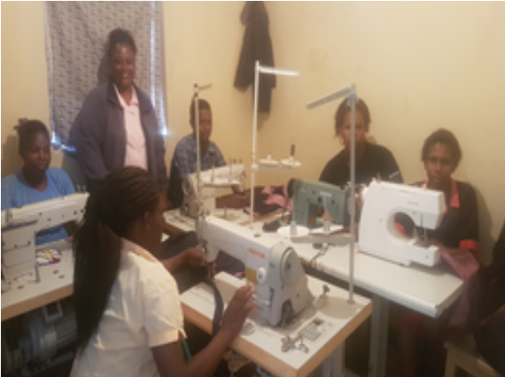
We have a new WEEP Class; 8 new WEEP beneficiaries started their class in February. PLK is living its mission and vision on empowerment, the beneficiaries are vulnerable young women in Mlolongo and hope this will ensure their economic engagement in future.

Tumaini School has continued to live its true meaning! With your support we have been able to touch the hearts and make the children smile through sponsorship

We have observed improvements in academic grades of importance improved health as a result of the feeding program..

Tumaini’s future looks good! Please share this good news with your families, friends and be proud for being part of that” smile”
Biogas at last!! Kiotani School has introduced use of biogas as clean energy strategy. Since the government imposed a burn on logging, it has been hard to get firewood/charcoal but now cooking can take place, thanks to New Hope. This will reduce the high cost of fire wood and charcoal and keep the new kitchen clean! (see above picture testing the gas stove)
The WEEP production unit, last month received a donation from Valarie of the Church of England- a multi-purpose electric machine that can be used for sewing, embroidery among other things. We hope to boost our production! Special thanks to Valarie.
NEW MEMBERS OF STAFF OF KIOTANI

NEW PLOT FOR TUMAINI SCHOOL
We have acquired a new plot, thanks for your support, we hope to build better structures for Tumaini School, baby care unit& a health facility .We will keep you updated and any ideas on how to achieve the dream are welcome.

